**Module 5 introduction**

**Learning objectives**

In this module, you will learn how to:

* Summarize the basic concept of storage and databases.
* Describe the benefits of Amazon Elastic Block Store (Amazon EBS).
* Describe the benefits of Amazon Simple Storage Service (Amazon S3).
* Describe the benefits of Amazon Elastic File System (Amazon EFS).
* Summarize various storage solutions.
* Describe the benefits of Amazon Relational Database Service (Amazon RDS).
* Describe the benefits of Amazon DynamoDB.
* Summarize various database services.

Video Transcript

Well, we have quite a coffee operation going now. We've got customers, lots of happy customers. In fact, we have an elastic, scalable, disaster resistant, cost optimized architecture that now has a global, highly secured network that can be deployed entirely programmatically.

You know, now we need some way to show our appreciation to all our loyal customers. How about a frequent drinker loyalty program? Or we could just hand out punch cards, but let's be honest, we can't track those well and use them to get to know our customers better.

We need digital cards, which means we need to be able to keep track of our customers, what they order, how much they purchased. This will help them, the customers, get the best rewards they've earned and help us to know our customer base better.

This means we need databases. Databases, and storage. And not just any database. We need to make sure we choose the right database for the task and the right storage for data types.

Now you may have many different data usage needs and data types. Let's learn about the different services AWS has to help you build the perfect data solution.

# Instance stores and Amazon Elastic Block Store (Amazon EBS)

**Video transcript**

–

When you're using Amazon EC2 to run your business applications, those applications need access to CPU, memory, network, and storage. EC2 instances give you access to all those different components, and right now, let's focus on the storage access. As applications run, they will oftentimes need access to block-level storage.

You can think of block-level storage as a place to store files. A file being a series of bytes that are stored in blocks on disc. When a file is updated, the whole series of blocks aren't all overwritten. Instead, it updates just the pieces that change. This makes it an efficient storage type when working with applications like databases, enterprise software, or file systems.

When you use your laptop or personal computer, you are accessing block-level storage. All block-level storage is in this case is your hard drive. EC2 instances have hard drives as well. And there are a few different types.

When you launch an EC2 instance, depending on the type of the EC2 instance you launched, it might provide you with local storage called instance store volumes. These volumes are physically attached to the host, your EC2 instances running on top of. And you can write to it just like a normal hard drive. The catch here is that since this volume is attached to the underlying physical host, if you stop or terminate your EC2 instance, all data written to the instance store volume will be deleted. The reason for this, is that if you start your instance from a stop state, it's likely that EC2 instance will start up on another host. A host where that volume does not exist. Remember EC2 instances are virtual machines, and therefore the underlying host can change between stopping and starting an instance.

Because of this ephemeral or temporary nature of instance store volumes, they are useful in situations where you can lose the data being written to the drive. Such as temporary files, scratch data, and data that can be easily recreated without consequence.

All right, I'm telling you not to write important data to the drives that come with EC2 instances. I'm sure that sounds a bit scary because obviously you'll need a place to write data that persists outside of the life cycle of an EC2 instance. You don't want your entire database getting deleted every time you stop an EC2 instance. Don't worry, this is where a service called Amazon Elastic Block Store, or EBS, comes into play.

With EBS, you can create virtual hard drives, that we call EBS volumes, that you can attach to your EC2 instances. These are separate drives from the local instance store volumes, and they aren't tied directly to the host that you're easy to is running on. This means, that the data that you write to an EBS volume can persists between stops and starts of an EC2 instance.

EBS volumes come in all different sizes and types. How this works, is you define the size, type and configurations of the volume you need. Provision the volume, and then attach it to your EC2 instance. From there, you can configure your application to write to the volume and you're good to go. If you stop and then start the EC2 instance, the data in the volume remains.

Since the use case for EBS volumes is to have a hard drive that is persistent, that your applications can write to, it's probably important that you back that data up. EBS allows you to take incremental backups of your data called snapshots. It's very important that you take regular snapshots of your EBS volumes This way, if a drive ever becomes corrupted, you haven't lost your data. And you can restore that data from a snapshot.

**Instance stores**

Block-level storage volumes behave like physical hard drives.

An [**instance store**](https://docs.aws.amazon.com/AWSEC2/latest/UserGuide/InstanceStorage.html) provides temporary block-level storage for an Amazon EC2 instance. An instance store is disk storage that is physically attached to the host computer for an EC2 instance, and therefore has the same lifespan as the instance. When the instance is terminated, you lose any data in the instance store.

## Instance stores

To review an example of how instance stores work, select **Start**.

START

**Step 1**

## An Amazon EC2 instance with an attached instance store is running.

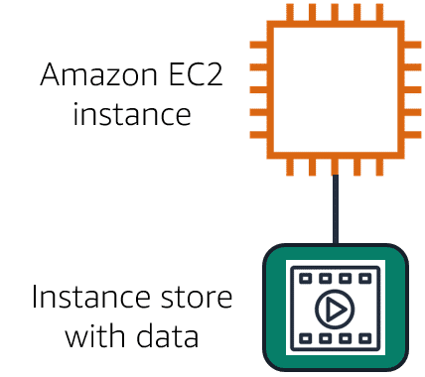

1

**Step 2**

## The instance is stopped or terminated.

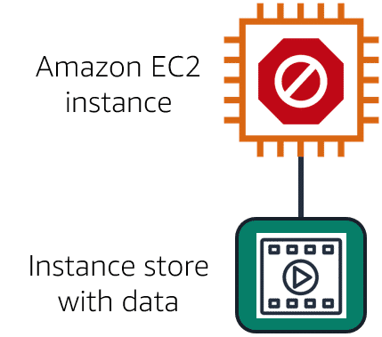

1

**Step 3**

## All data on the attached instance store is deleted.

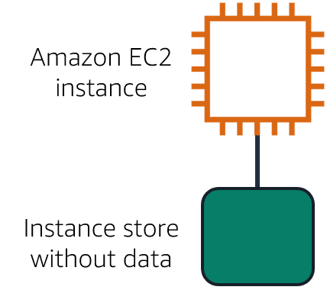

## Summary

Amazon EC2 instances are virtual servers. If you start an instance from a stopped state, the instance might start on another host, where the previously used instance store volume does not exist. Therefore, AWS recommends instance stores for use cases that involve temporary data that you do not need in the long term.

[**Amazon Elastic Block Store (Amazon EBS)**](https://aws.amazon.com/ebs) is a service that provides block-level storage volumes that you can use with Amazon EC2 instances. If you stop or terminate an Amazon EC2 instance, all the data on the attached EBS volume remains available.

To create an EBS volume, you define the configuration (such as volume size and type) and provision it. After you create an EBS volume, it can attach to an Amazon EC2 instance.

Because EBS volumes are for data that needs to persist, it’s important to back up the data. You can take incremental backups of EBS volumes by creating Amazon EBS snapshots.

**Amazon EBS snapshots**

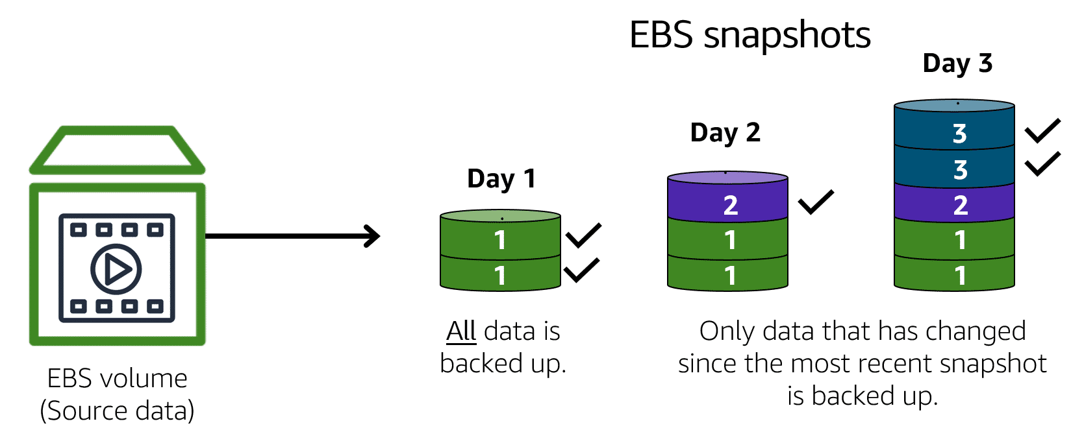

An [**EBS snapshot**](https://docs.aws.amazon.com/AWSEC2/latest/UserGuide/EBSSnapshots.html) is an incremental backup. This means that the first backup taken of a volume copies all the data. For subsequent backups, only the blocks of data that have changed since the most recent snapshot are saved.

Incremental backups are different from full backups, in which all the data in a storage volume copies each time a backup occurs. The full backup includes data that has not changed since the most recent backup.